1.3 Representing and Describing Transformations

Transformation: is a function that changes the ____________, _________________, and/or _________ of a figure
Preimage:
Image:

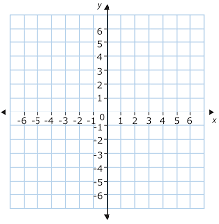
Triangle ABC: A(0,0) B(2,3) C(3,1)

- ( x , y ) → ( x – 4 , y – 3 )

- ( x , y ) → ( -x , y )

- ( x , y ) → ( 2x , y )

Rigid Motion: ( or ____________) is a transformation that changes the ___________ of a figure without changing the ___________ or __________ of the figure

Try Your Turn #5 and 6

Try Your Turn # 8 and 9

