Prove that the triangles are congruent

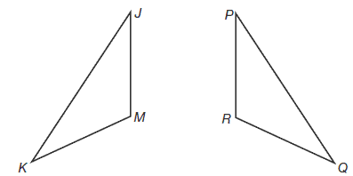

Use a protractor to check angles:
<J= <p=
<M= <R=
<K= <Q=

Use a ruler to check side length:
JK= PQ=
KM= QR=
JM= PR=

