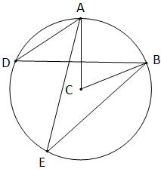
Circles Test Review Name: _____________

For questions 1 – 3 use the figure at the right.
- Name a Chord.

- Name a central angle.

- Name an inscribed angle.

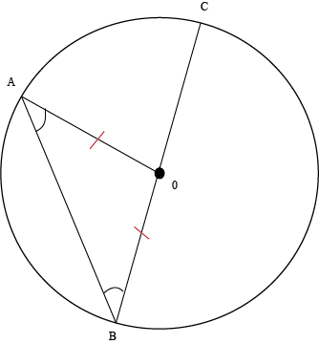
For questions 4 – 6 use the figure to the right.
- Name a minor arc.

- Name a major arc.

- Name a semicircle.

- Using the figure below if <NLP is 68° then what is arc np? If arc LP is 92° what is <PNL?
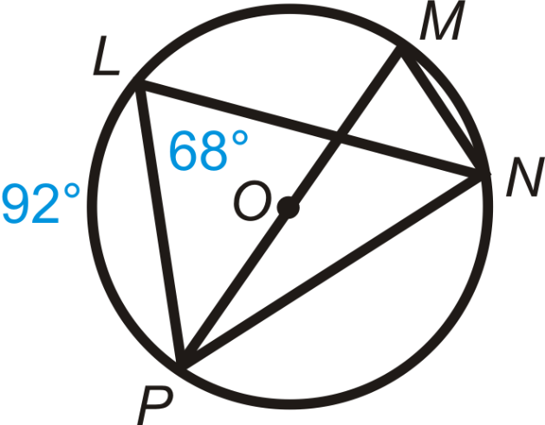

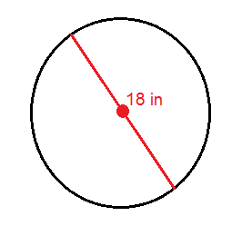
- What is the circumference of the figure to the right? What is the area?

Circumference_____ area_______

- If the circumference of a circle is 100ft, what is the diameter?

- What is the length of arc AB if the radius is 12 ft? What is the area of the sector AB?
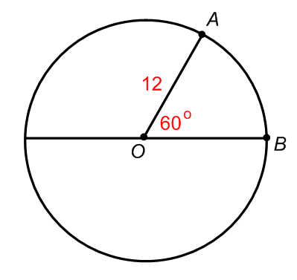arc length_______ Sector area ________
- A college puts in a mini running track inside of one of their rec buildings. The track has two strait lengths that measure 28.13m and two semi circle ends with an inside radius of 12.16m. What is the length of the track?
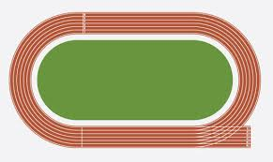
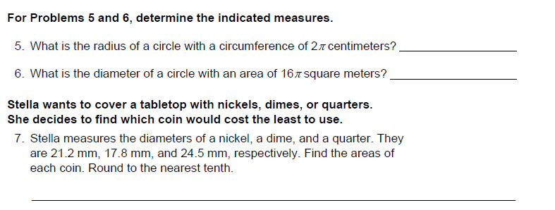
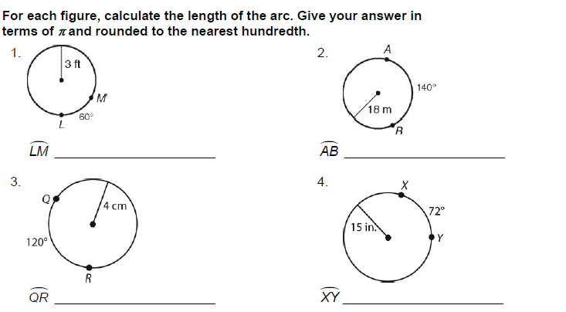
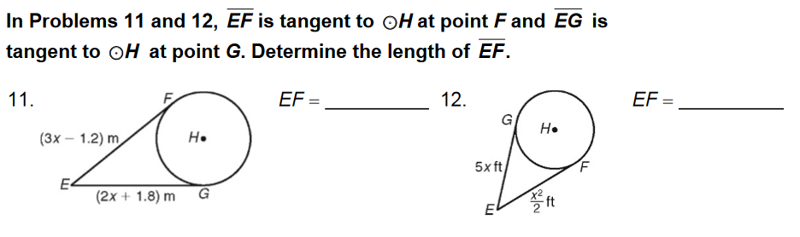
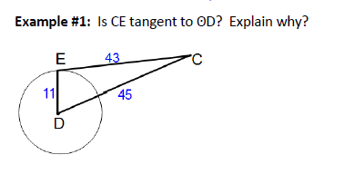
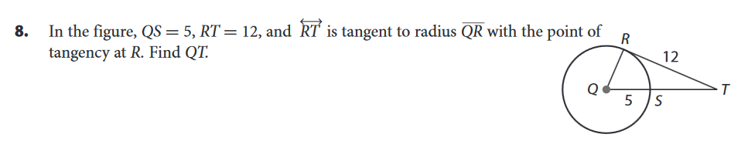
Is AB tangent to circle C? Explain why?
